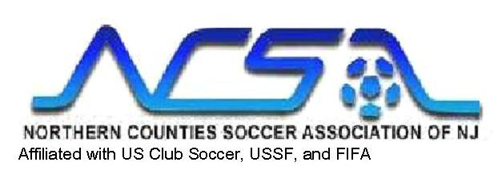
GAME DAY FORM
To be completed and presented to referee by Home Team

Match No:  Date: | Boys () Girls () | Age Flight  U-
Field: |  | Time:
Home Club/
Team Name
Opponent Club/
Team Name
Referee Name
Div/Age | Duration  (Halves) | Overtime (Play off) | Ball | Ref Fee | AR Fee
1 (U17- U19) | 45 min | 2-15 min | #5 | $70 | $40
2 (U15- U17) | 45 min | 2-15 min | #5 | $70 | $40
3 (U13- U14) | 40 min | 2-10 min | #5 | $60 | $35
4 (U11- U12) | 35 min | 2-10 min | #4 | $54 | $30
5 (U9- U10) | 30 min | 2-10 min | #4 | $44 | N/A
6 (U8) | 30 min | 2-10 min | #3 | $44 | N/A

CODE OF CONDUCT AND COACHES’ CERTIFICATION

All coaches participating in this game must read and sign this certification. References to singular include the plural.

- I am (We are) the licensed and carded coach(s) responsible today for the above team
- I have read, am familiar with and understand the rules of NCSA applicable to my team and to this game. We understand that only carded coaches who have signed the roster may coach or provide direction to the players.
- I promise to treat all players, coaches, spectators and officials with respect that I would want toward my children, family and friends.
- I have discussed at least once this season with my players their responsibilities and proper conduct and behavior towards players, coaches and officials under FIFA and NCSA rules.
- I have discussed at least once this season with, and given a copy of this code of conduct to, all parents and team supporters of players participating in this game proper behavior as spectators at a youth sports event, including:
- Encourage your team (but only the coaches coach)
- Treat the opposing team (players, coaches, spectators) with respect as you would treat your own child, your team’s coach and fellow spectators
- Treat the officials with respect; dissent of any type, by word or action, is prohibited by FIFA rules
- No alcohol and no smoking of any type within view of the players and the field during games.
- As adults and especially as coaches, we must set a good example for the players and other young persons present who will follow our conduct.
- I certify that the US club Roster submitted to the referee contains the correct player information, uniform numbers and is current as of today’s date.
- I have checked and verified that the goals are secured (all game day coaches and referee print name and sign below)

Print Coaches Names Participating in this Game (as they appear on your US Club passes) (Max 4 Coaches on sideline) | Signatures
Home Coach:
Home Coach:
Home Coach:
Home Coach:
Visitor Coach:
Visitor Coach:
Visitor Coach:
Visitor Coach:
Referee (print name here, then sign to the right):
(pertains to #7 only – secure goals)
Referee:
Attach this form to US Club Team Rosters and mail with your Referee Report to: NCSA Referee Office; P.O.Box 26, Ho-Ho-Kus, NJ 07423

ENJOY THE BEAUTIFUL GAME
Revised 8/2008

